SmartCare v0.2 - Requirements Specification Template

1. Problem and Scope
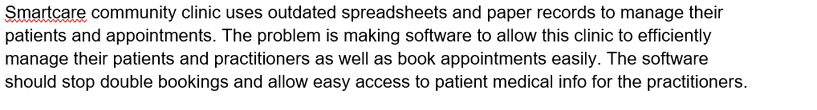

Scope
Feature | Scope | Status | Source/Reason
Appointment management (book and view) | In Scope | Confirmed | Client asked for software to manage patients, practitioners and appointments
Patient search | In Scope | Confirmed | Brief lists difficulty locating patient records
Staff can cancel appointments | In Scope | Confirmed | Brief lists manual cancellation processes; your Stage 2 functional requirement
Cancelled appointments remain in history | In Scope | Confirmed | Brief lists lack of reliable appointment history
Prevent duplicate bookings | In Scope | Confirmed | Brief lists duplicate bookings; your receptionist need
Practitioner schedule view | In Scope | Provisional | Brief says visibility of availability is limited but not whose; your "assumption requiring validation"
Receptionists create appointments | In Scope | Provisional | Brief never names the receptionist role; your "assumption requiring validation"
Audit trail / reason for cancellation | In Scope | Provisional | Management need from stakeholder map; not in the brief
Detailed reporting | In Scope | Provisional | Brief mentions only basic operational reports; management wants more detail
Fast, minimal data entry | In Scope | Provisional | Doctors' need; "fast" isn't measurable yet
Secure patient records | In Scope | Provisional | the brief doesn't mention security
Simple, maintainable code | In Scope | Provisional | IT Support need
Facial recognition login | Out of scope | n/a | Too complex for a simple small-clinic system
AI diagnosis / treatment recommendations / treatment plans | Out of scope | n/a | Clinical, not administrative; liability concerns
Insurance processing | Out of scope | n/a | Not in the brief
SMS reminders | Out of scope | n/a | Nothing in the brief about patient notifications
Online payment | Out of scope | n/a | Not in the brief

2. Stakeholders
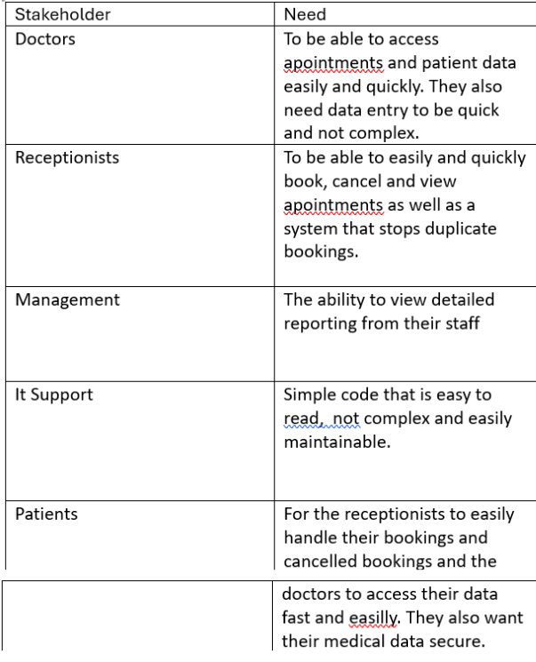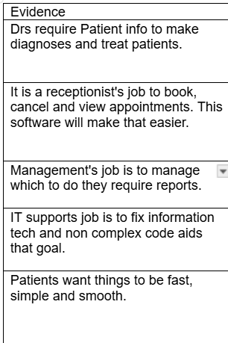3.
Functional Requirements
Fr-01 = The system shall allow staff to register a new patient record.
Fr-02 = The system shall allow staff to search for a patient by patient ID.
Fr-03 = The system shall allow staff to create an appointment by recording a patient, a practitioner and an appointment time.
Fr-04 = The system shall reject a new appointment if the patient, practitioner or time is missing.
Fr-05 =The system shall reject a booking when the practitioner already has an appointment at the requested time.
Fr-06 = The system shall allow staff to view all appointments.
Fr-07 = The system shall display the current status of each appointment.
Fr-08 = The system shall allow staff to cancel an appointment.
Fr-09 = The system shall retain a cancelled appointment in the appointment history rather than deleting it.
Fr-10 = The system shall allow staff to view the appointments and available times for a given practitioner. (Provisional)
Fr-11 = The system shall produce a basic report showing the number of appointments by status. (provisional.)

4. Non-Functional Requirements
Nfr-01 = The system shall never store two active appointments for the same practitioner at the same time, and every appointment shall refer to an existing patient and practitioner.
Nfr-02 = Patient and appointment data shall still be present after the system is closed and restarted.
Nfr-03 = Booking and cancellation rules shall be kept separate from display and storage code, so a change to one does not require changes to the others.
Nfr-04 = Core business logic shall be testable without the user interface, and every functional requirement shall have at least one test.
Nfr-05 = A receptionist with no prior training shall be able to book an appointment in no more than 5 user actions. (Provisional)
Nfr-06 = Patient search and appointment display shall return results within 2 seconds for the course-scale dataset. (Provisional)

5. User Stories
Us-01 = As a receptionist, I want to book an appointment by entering a patient, a practitioner and a time so that the visit is recorded without using spreadsheets or paper.
Us-02 = As a receptionist, I want the system to stop me booking a practitioner who is already booked at that time, so that duplicate bookings no longer happen.
Us-03 = As a receptionist, I want to cancel an appointment quickly while the record stays in the history so that cancellations are easy but the clinic still has a reliable record of what happened.
Us-04 = As a receptionist, I want to search for a patient by ID, so that I can find their record quickly instead of looking through paper files.
Us-05 = As a receptionist, I want to know if I type in a patient id that does not belong to a patient.

6. Acceptance Criteria
Given Dr Ridley does not already have an appointment booked on 2024-07-20 at 2pm, When a receptionist tries to book an appointment with Dr Ridley on 2024-07-20 at 2pm, Then the system books the appointment and saves it into the database.
Given Dr Ridley already has an appointment booked on 2024-07-20 at 2pm, When a receptionist tries to book a second appointment with Dr Ridley on 2024-07-20 at 2pm, Then the system rejects the booking and shows an error message saying that dr Ridley is already booked at that time and only the original appointment is stored.
Given an appointment for a patient with Dr Ridley exists When the receptionist cancels the appointment Then its status changes to cancelled. It still appears in appointment history but now Dr Ridley can be booked again.
Given patient id p001 belongs to Jane Doe When the receptionist searches p001 Then Jane Doe's record is displayed.
Given patient id p011 belongs to no one When the receptionist searches p011 Then patient not found is displayed.

7. Assumptions and Open Questions
Questions
How many users will use the system at once?
Does the software need to manage/calculate insurance and costs.
Will patients be logging in to book their own appointments or will staff be doing it for them?
Are you planning on migrating all paper records into digital records?
What is your budget and timeline for creating and testing this new software?
Assumptions
Receptionists create appointments: the brief says the software should manage appointments but doesn't say receptionists are the ones booking them.
Practitioners view schedules: the brief doesn't explicitly say practitioners can view their own schedule.

8. AI Requirements Review Record
